Brain storm and research
综述型文章：file:///C:/Users/%E7%88%B1%E5%90%83%E5%90%83%E7%9A%84%E7%9A%84Sarah/Downloads/91c-full.pdf

Definition based: Happiness is not a state. Happiness is a skill
Based on instinct instead of sole reasoning(turning happiness into numbers). Confucius--饭疏食，饮水，曲肱而枕之，乐亦在其中矣。不义而富且贵，于我如浮云

Common methods used for measure:
Biological
Test the amount of dopamine, serotonin....
Can only know someone is not happy, but they cannot know whether he or she is happy.
Same as the limitation of james lange theory--same arousal, but the identification of emotion is limited.

Authentic Happiness Inventory; “satisfied individuals report higher satisfaction with life through ‘meaning,’ ‘pleasure,’ and ‘engagement’”; positive psychology can then intervene
https://positivepsychology.com/measure-happiness-tests-surveys/

“[…] experiencing and savoring pleasures, losing the self in engaging activities, and participating in meaningful activities”; Seligman et al. 2005; p. 414). Consistent “flow” is a form of happiness, since he/she gain a strong ability to create flow. But turning happiness into numbers is not reliable.

Reject:
Measurement from
Measurement from positive psychology fail to consider one’s unconciousness and ignore the change in time horizon.
Counfounding variable
- Unconciousness--defense mechanism; sadness is been shielded by unconciousness. But this part of a person should be considered in the evalution of happiness. 越过心里那座山--牢笼
(Moreover, sadness in the past is likely to be devaluated as time goes because of the elimination of cognitive dissonance. Then the measurement cannot reflect one’s skill.)
https://doi.org/10.1111/j.2044-8295.1968.tb01128.x
- Not realistic. Based on situation(此刻幸福的人更容易认为自己的常态是幸福)---but fail to consider that happiness is an ability: he or she may have the ability to restore interpersonal relationship, or to transcend in his/ her own mean. But with the rightnow situation, people fail into the loop of over optimistic and over pessimistic---confirmation bias: Only paying attention to information that confirms your beliefs about issues
https://www.verywellmind.com/cognitive-biases-distort-thinking-2794763Amplify certain emotion and ignore the others
file:///C:/Users/%E7%88%B1%E5%90%83%E5%90%83%E7%9A%84%E7%9A%84Sarah/Downloads/91c-full.pdf

Example：活出生命的意义。不可能认为自己是幸福的，但是心中的火种让他最后跳脱出极大的磨难。幸福的衡量本应该涵盖人们创作幸福的能力，但是谁又知道未来我是否会重新站起？

Confucius--失意，不被重用，但是坚守内心的哲学理论，跳脱社会所认为的价值体系--这难道不是幸福吗？
幸福无法被衡量，
Reject-目前已有的衡量方式：生物上，自测的方式，联合国的测试方式

幸福是超越状态的，是一种能力
- 受到外界的裹挟
衡量的尺度被时代定义
活出生命的意义--在当时的时代，没有人会把历练人视为幸福。如果那一部分的pain是happiness的一部分，那么在测度ordinal function的时候，应该把这部分历练涵盖进去，但是没有人涵盖。Exhaustion
- 它常常是跨越时间维度的。对个体本身而言都是一个难以用言语表达的
苏东坡的happiness--那个时代不认可他，但是找到自我的意义--不取决于外在，但是外在决定meaning的定义

- 人们难以把痛苦视为幸福的一部分
Sartre Says, that ‘Being precedes essence’ （如果测度出的幸福只是一个当下的状态，那人们如何保证他的时效性，意义在何处？）
Exsitential psychology
痛苦本身就是幸福的一部分，但是在衡量的时候会被遮蔽
Simply put, existential psychology is about human existence and the human drama of survival and flourishing in spite of suffering and death. It is inherently positive, because it emphasizes the courage and responsibility of confronting existential anxieties and living an authentic life.
http://www.drpaulwong.com/wp-content/uploads/2013/09/what-is-existential-positive-psychology.pdf
人在抽离后往往才是幸福，测度的范围是抽离前的问题（职业）--屏蔽可能的选项；有限无限的游戏，与哲学家谈快乐

Meaningful--反应的是能力，但是问卷只能看到状态
人不是被事情困扰，而是被他们关于事件的意见困扰。Schema--how to test? Not in action

当前已有测量方式的局限性
无论再怎么修改都不能消除的局限性

何为幸福？
幸福的定义
幸福是一种内在的感知力和坚守的能力，而不是一个状态
梭罗，孔子,伊比鸠鲁，陶渊明,

Happiness cannot be measured
Internally enriched
“Meaning”--defined by externality
Happiness is a skill instead of a state

Subjectively measured
Don’t need a common ground

Measure--ordinal or cardinal?
Superior happiness
Take all happiness into account--不在一个量纲上--how to measure then?
Meaning can be a form of superior happiness, connect with law,,,
But meaning

Measure in utility

Utilitarian/
Outside of your control--fail in meaning

现在幸福，未来不幸福/现在不幸福，未来不幸福--essence comes before existence?

pain is a part of happiness,
but people normally fail to
recognize that (world war
II)

Le can be extended after death, an infinite game for the purpose of continuing the play.

Cannot measure in form of numbers or inventories, but only can be felt by oneself.

Measure: quantitative description from externality.

Limitation of measurement of happiness
Bias leaded by culture--p8
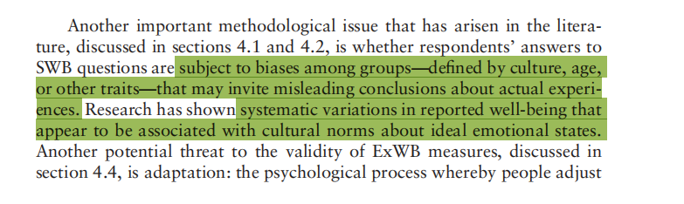

现在幸福，未来也幸福

如果meaning本身就需要与外界有连接，那么inner life+externality would help us feel a sense of euda

Pursue of goal and meaning:
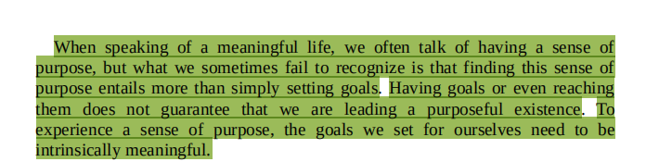
Ordinal:
Meaning not necessarily bring pleasurable experience
比如带孩子可能是meaningful的，人在过程中认为自己more capacity，这个过程也会越来越meaningful
存在先于本质
对meaning真正的认知如果一直在变动，measure是一个静态的，不在一个层面上

Both involved a signaling process toward the externality
存在先于本质 meaning是当下的存在还是本质？
Meaning exceeds even if people died
His/her intrinsic value cannot be asked, not ordinal
ordinal的排序包含了自身和外界的expectation，meaning本身就是参杂的：有的人认为完全追求自我是meaning,有的人认为完全的meaning是奉献于社会。因为meaning在ordinal中的衡量是自身价值的排序，所以在一个present moment下，人们的ordinal utility是可以被衡量（static model）
但是当引入时间为变量时，meaning无法通过ordinal utility function测量。存在先于本质，不断迭代，当人
Interestingly, this research, and that of others,5 6 is consistent with a much more dynamic view of free will in which concepts describing the self are fluid self-interpretations influenced by factors such as social contexts, knowledge acquisition, experience, and culture.

static philosophical scholasticism

帮助别人（happiness指标）但是自己不愿意--moral，not real happiness

. One of the attractions to policy makers
of the constructs of evaluative and eudaimonic well-being is that they allow
for consideration of nonhedonic sources of happiness and suffering.

Sentiment analysis

Happiness measure要经过的过程
- 对自我的评估
- 对外界的表述（interaction between the self and the externality)/基于外界的scope来respond
--fail in two processes

Measurement的定义：Self evaluation
Happiness的定义：approach “meaning”
放弃现在和未来-self-regard would be lack of meaning

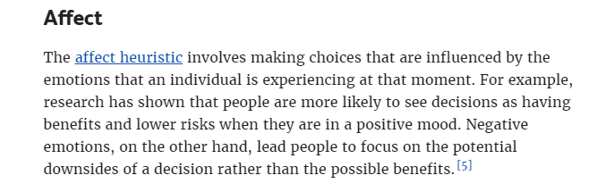
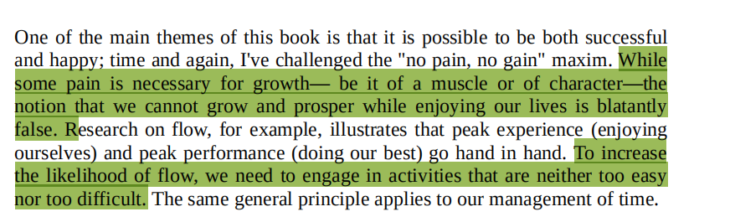
Second aspect:
Pain is a part of happiness. So what part of pain should be included? Some people regard that raising children is daunting and meaningless--because they are overloaded with meaningful things; some people perceive a sense of flow while they are raising their children
Language--even though we have common perception, but the inaccuracy still cannot let the externality realize what people perceive

People perceive good and freewill--but virtually they disregard others’ freewill--love( the evaluation fails to start with a point and end with a point)

They are fully integrated
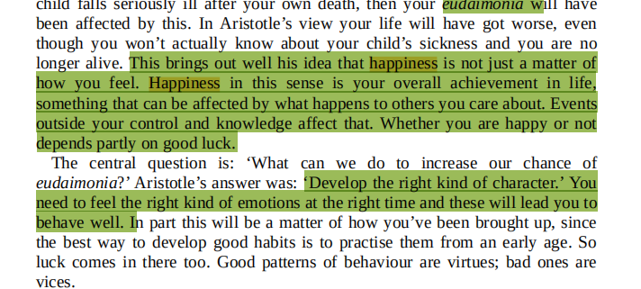

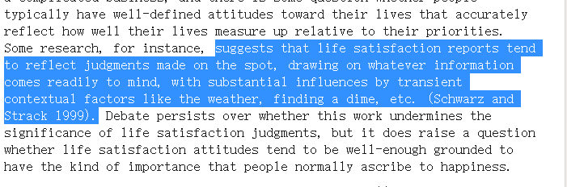
Heuristics
emotional state view (Haybron 2001)
--suffer may be a part of happiness
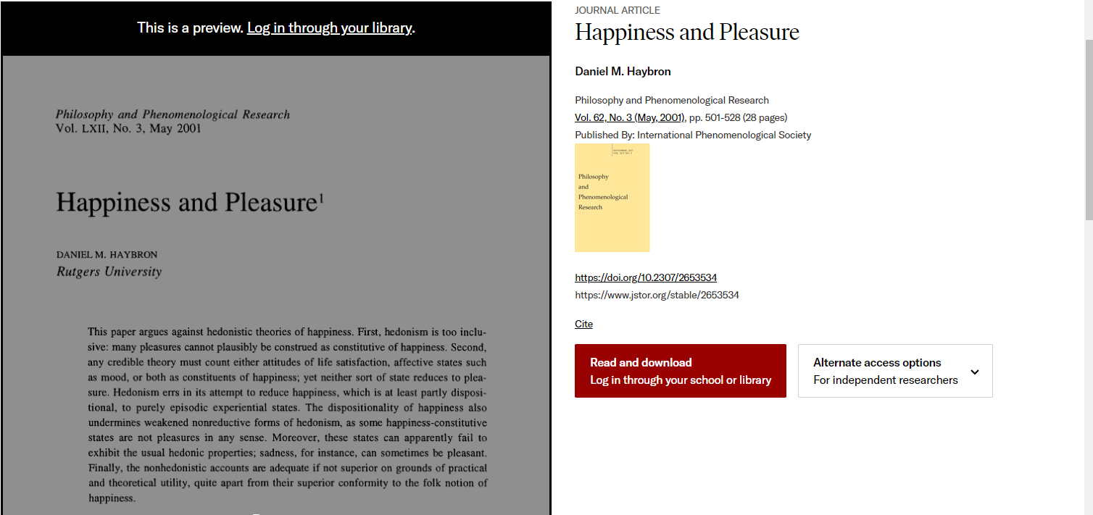
Experience a sense of flow
Happiness-happiness
Bentham--not on the same stage
The understanding change with time

Internal ability

Subjective measurement--overconfident?cognitive bias.
Data collection--cognitive dissonance, externality’s expectation

A person who perceive his life lacks happiness, but still rate himself as happy. Possible sources1) social expectation, wealth. Under the society expectation, No reason to feel sad 2)
Confirmation bias
-->persist this manner, living in this happy manner
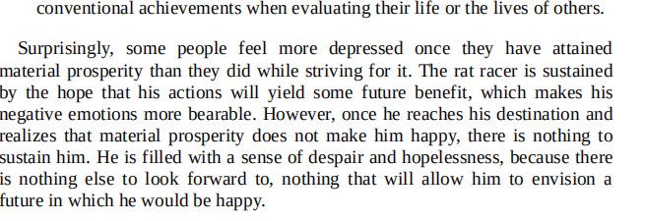
Equate wealth and reputation as happiness
Reference point always move upward--loss averse--same amount of loss and gain cannot offset each other, but its asymmetry will lead to the accumulation of dissatisfaction. At that time, rat racers still believe that it’s because the reference point is not high/desirable enough, falling into their 认知边界
Neuro-Logical Levels
Finite game
serves for future happiness, evaluating their activities as meaningful. However, this understanding does not reflect the real happiness.

Type A personality

Cognitive dissonance
Can people be honest to themselves even though they stay alone?
Influence of group culture
I have no reason to feel not happy; sadness is a shame( meaning to one’s life); they disregard their pain. Self-pushed happiness

Culture’s effect and

I love study. Study is a way to scoop me away from sadness, anxiety, and void

System II reinforces on the interaction between externality and internality, and with its effort, respondents may temporarily stop from
directs attention on external environment, and therefore perception could happen.

However, from evolutionary perspective, the directing attention can be easily distracted by external stimuli since the scenarios in outer life can be more related with human beings’ survival (Fiebelkorn et al., 2018). Moreover, the activation of system II requires an input of energy, and human beings have natural tendency to conserve energy (Thinking, fast and slow). With these biological factors, human beings rely heavily on automatic states and put less effort on exploring oneself.

We can only direct our attention to a few pathway
Selective attention
Direct large proportion of attention to externality
Effortful processing
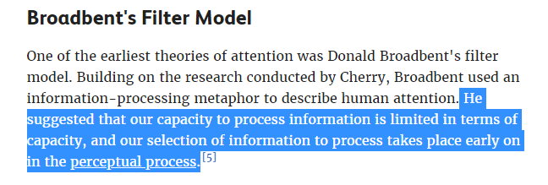
To feel the change of brain activity--perception--first requires attention

(question about citation:

No twice.
Same book
- Intext citation?
Moreover, under the value system that “unhappiness is a symptom of maladjustment” (Frankl, 2006b, p. 136), respondents may hide their willingness more to conform social desirability and to reduce their cognitive dissonance .
yes
- Chinese book citation?
Translate and check more

independent thought, depth of knowledge, clear reasoning, critical analysis and persuasive style.

Truth, free will
Make the benchmark of happiness consistent: externality-formed happiness, or individual-based happiness
If it is individual-baed happiness, then I cannot defend others’ happiness
If it is externality-based happiness, then what is the truth, the happiness?
If free-will can conciously alter our original belief, human beings may have possibility to explore the truth. I think The common sense of happiness exists across culture and individuals. That common sense can also alter with time horrizon-->deviate from truth or not deviate? Doesn’t matter! The existence of free-will allows people to explore consciously about the truth, but whether the truth exist

Even though the external benchmark exist, does this mean people have the ability to measure happiness?
Hedonism, nihilist....all these hinder people to perceive the benchmark of happiness
Externality can only approach the external benchmark
The meanstream culture is only what nowadays perceived as happiness
If the truth doesn’t exist, the existence of free-will will be meaninyless since what people explore is only limited an given answer.

Introduction
Philosophers give different connotations to happiness. Confucius believes joy lies in the moment of “eating coarse greens, drinking water, and crooking one’s elbow for a pillow”. Epicterus believes happiness is a sense of serenity that can be derived from acceptance toward events out of control (Martin, 2007). Not only do philosopher, but individuals also develop their understandings toward happiness diversely (Oishi et al., 2013). However, despite understandings are different, we commonly find that happiness blends inseparably with the simple physical sensation and incorporates both eudamonic and hedonic ends (Haybron, 2011).
That means happiness exists in a form that diverges among individuals’ inner experiences but can be extracted and perceived as a common sense. Based on this understanding toward happiness, this essay argues that happiness cannot be measured in subjective well-being test(SWB)(Stone et al., 2013).

Inner life--different
Perception exist--externality
The subjective measurement
Aristotle considers eudamonia as “living a fully realization toward life (Fowers, 2016).”
Philosophers develop their understanding toward happiness diversely, but at the same time, they commonly regard that happiness blends inseparably with the simple physical sensation and happiness incorporates

[futher explanation see endnote]

Confucius said, “To eat coarse greens, drink water, and crook one’s elbow for a pillow, Le also lies therein.” Le, which is translated to joy, is inherent in Confucius’ mundane life. Eventhough he was forced to resign his post and go into exile, he still perceived a strong sense of Le and pursue his highest good. And this sense of Le would be regarded as a form of happiness.
Happiness is an elusive concept. Individuals living with different time period and cultural background would give different connotations toward happiness(Oishi et al., 2013). From Confucius, we can perceive a common sense of internal enrichment. This sense of happiness is highly in accordance with superior happiness in the greatest happiness principle, which far exceeds the satisfaction receive from physical sensation. However, similarly, both sense of happiness blend inseparably with the simple physical sensation, turning into distinctive forms that exceeds corporal restriction (Riley, 2013).
Based on this understanding toward happiness, which reinforces on eudamonic happiness but not exclude hedonic happiness, this essay will argue that happiness cannot be measured in subjective well-being test (SWB) (Stone et al., 2013).
The logic of measuring happiness is similar to the logic of Plato’s theory of form--the idea of a perfect circle can only exist in its form, but doesn’t exsit in reality. Similarly, people can only measure specific aspects of life to approach happiness, but the real happiness only exsits in perception, not exsit in subjecitive measurable form.

Their personal criteria stand on “knowing”
But we hard to know ourselves
We believe that some sources can bring happiness to this moment, but then they cannot--looking at a scenery--
Internal feelings
Possible cognitive limitation that disallow human beings to discover their essential happiness.
Whether you are happy or not, is dependent on your subjective belief. This belief is limited by coginitive limitation.
Judging one’s happiness

Consciousness
inner source of truth
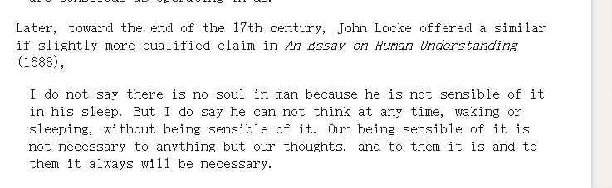
Only being sensible can allow us to discover our thoughts
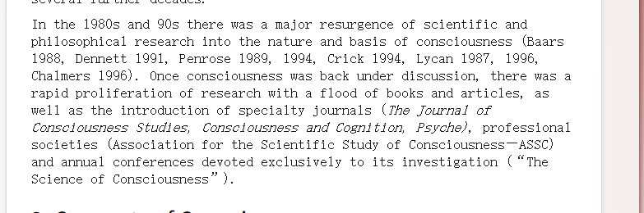
Self consciousness
Requirement:
但是第三方的视角只能起到辅助作用
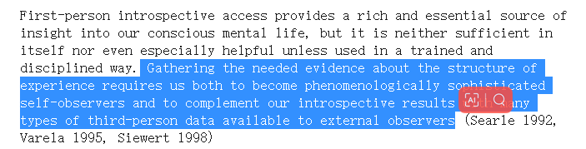
As Kant (1787), Husserl (1913), and generations of phenomenologists have shown, the phenomenal structure of experience is richly intentional and involves not only sensory ideas and qualities but complex representations of time, space, cause, body, self, world and the organized structure of lived reality in all its conceptual and nonconceptual forms.

Theory construction and ingenuity--光是introspection，不能行
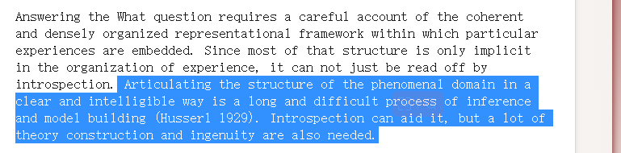
第三方难以接入
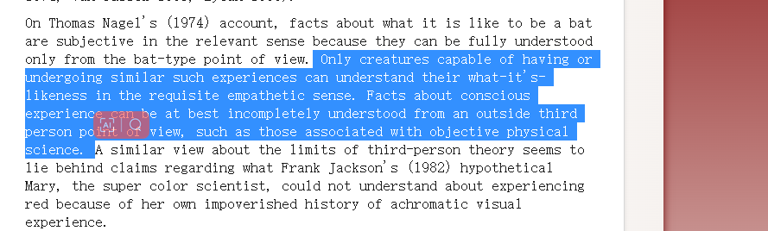
Consciousness with externality:
与外界和自我都很相关
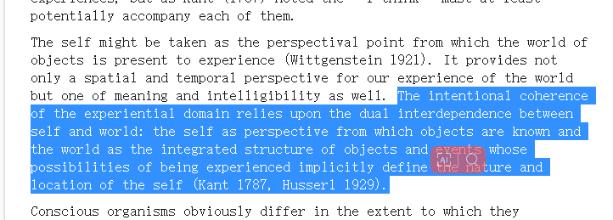

What is consciousness
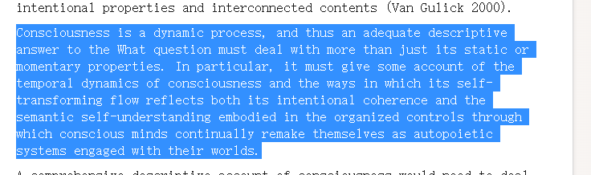
The criteria of explanation is not stable

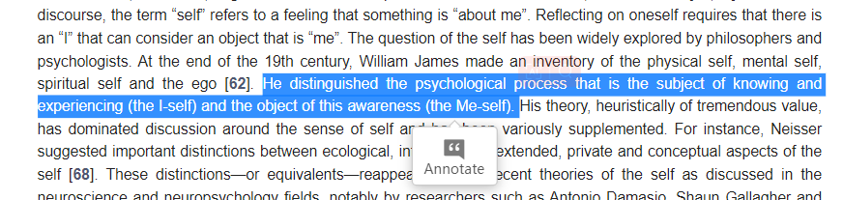
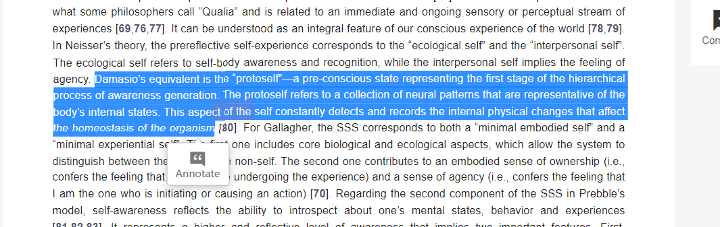
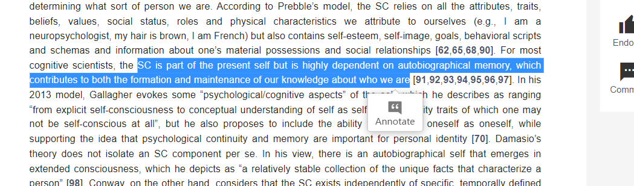

Memory is helpful for I-self, but it may decay
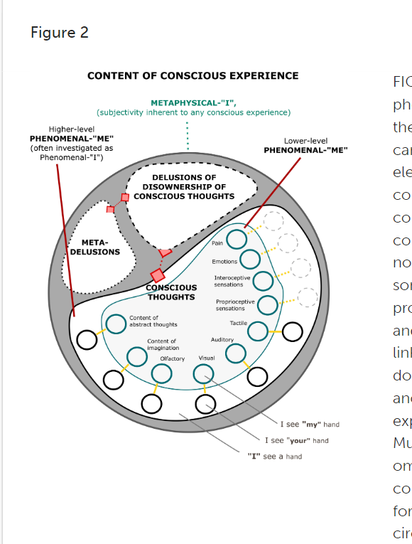
Self-knowing

Self ciousness
Locke, Kant
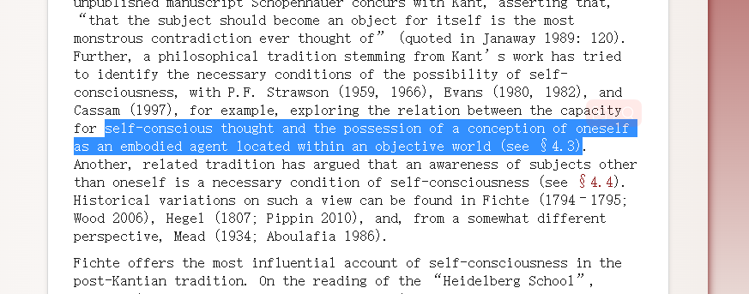

No continuous transcendent ego
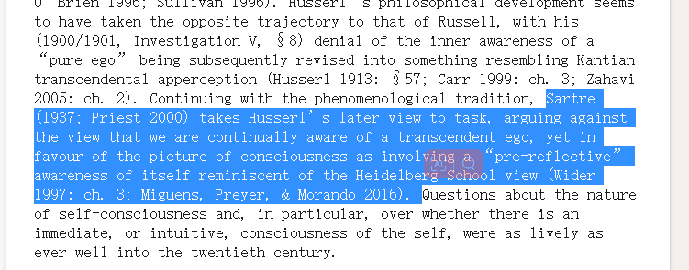

Memory and self-conciousness
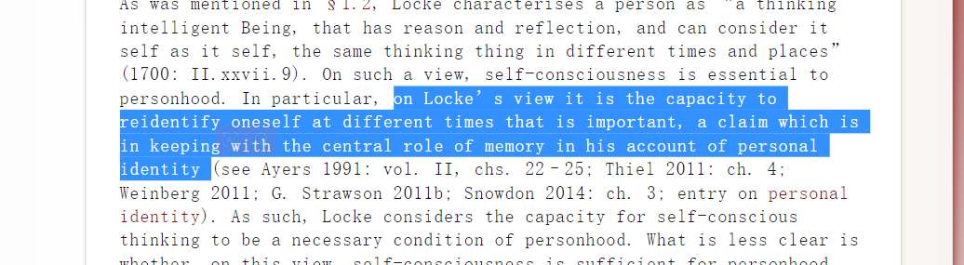
Second order volition
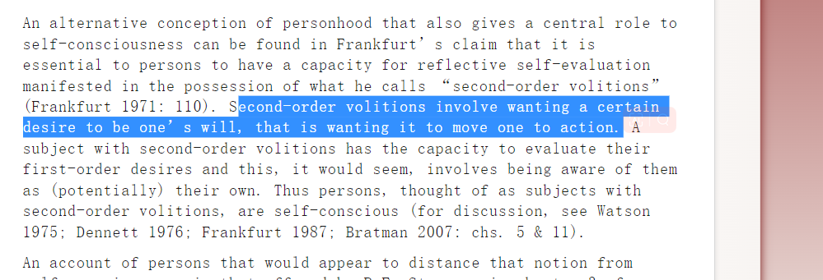
Many entities
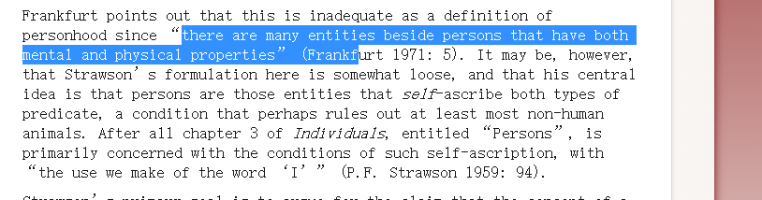
Secobd-order thinking (metacognition)
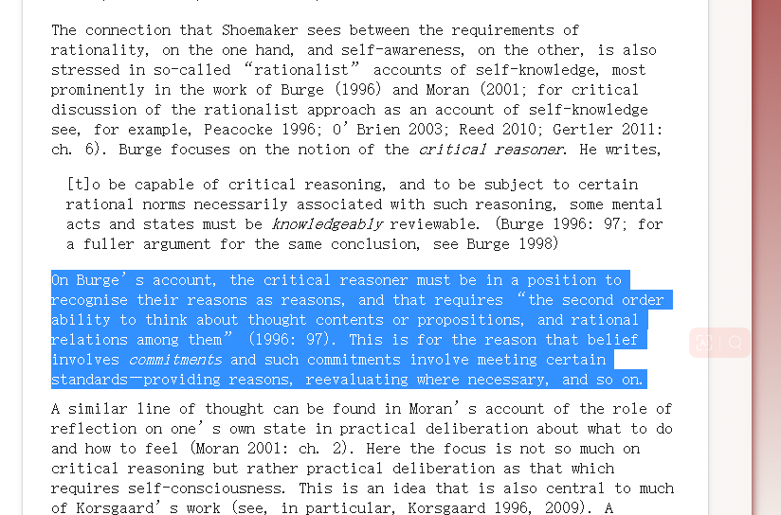

4.3 Self-Consciousness and Consciousness

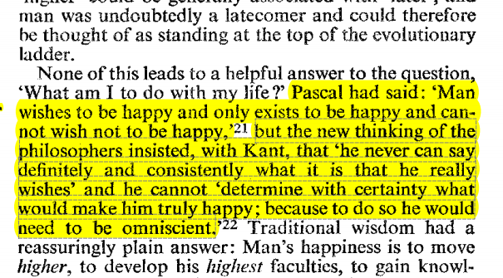
Higher condition
Self-limited--->metacognition and system 2
Toward past--memory--decay
--limited
Third party--not consistent

Happiness can be not a common sense, but one is hard to discover one’s benchmark
General assumption:
Blend inseparably with physical sensation--that means the knowledge toward perception is associated with happiness. --Sensitive knowledge--not sole intuition that based on existing interpretation
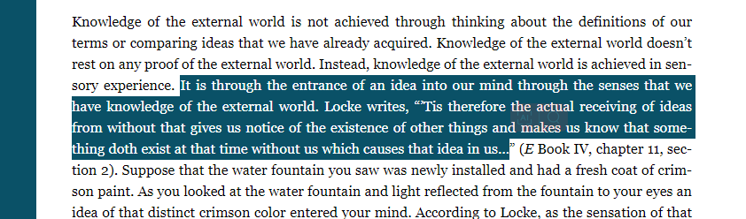

One can rarely knows oneself--general assumption
What is knowing
Knowing is self-awareness.
How a person can know him/herself
Recognition of perception
Metacogntion and system 2--explore within the frame
Lots of things are outside of frame. Even within a person. Memory can contribute to self-knowledge, but its decay disallow individuals to discover it(episodic memory)

Externality--third party--but different perception
Exploration of cognition. Just as ...says, move to higher level

What barriers may face when one try to explore oneself

Corteen and Wood (1972) discovered that even when words didn’t consciouslly perceived by participants, they still established meaning.

To achieve knowing, I suggest that one first needs to discover the raw form of knowledge. Locke writes,

In Tao Te Ching, Lao-Tzu believes that “ He who knows himself is enlightened.” Knowing is the zero condition to discover one’s essential state of happiness, but to achieve knowing, one needs to be fully self-awared (Schumatcher).
(common ways to discover state)
By invoking system II (Kahneman, 2011) and metacognition, human beings can explore their inner thoughts more thoroughly. However, from evolutionary perspective, the activation of system II requires an input of energy, and human beings have natural tendency to conserve energy (Kahneman, 2011). Moreover, people are likely to direct their divided attentions to external environment. Corteen and Wood (1972) discovered that even when words didn’t consciouslly perceived by participants, they still established meaning. Therefore, without directing attentions fully to the process of thinking, it would be uncertain whether a man knows him.

Happiness: I think I am happy
Happiness is the archetype that has the highest possibility of approaching the knowing, since they believe that they have the potential of discovering one’s maxim of happiness. With the belief to transcend, they take happiness more as a dynamic skill that detaches from established experiences and momentary states. However, while the perception turns to explicit rating within oneself, possible bias may occur during the construction of frame. For instance, about what contribute to one’s happiness, individuals take certain aspects as the main cause, but the ignored intricate associations among these aspects are also essential for gaining happiness. As gestalt psychology illustrated, one’s understanding “seem to depend upon relations among the stimuli rather than upon the individual stimuli as such (Kohler, 1967).”

-->connectionalism
Connectionalism only trigger several possible nodes.

归因--错综复杂

Under this archetype, it also includes state-dependent beings.
Gap between belief and language--belief and inner voice

First, since there is a lack of distinction between state and skill, due to affect heuristic, individuals’ prediction toward futurehave natural tendency to make decisions and predictions based on state at that moment. Experiment also demonstrates that people living in momentarily peaceful state are more likely to report high satisfaction toward their entire life (Schwarz & Clore, 1983). Therefore, respondents who may not be happy in the future still report that he will experience happiness right now, which leads to a bias

To measure individual-based happiness effectively means the test is able to incorporate different understandings toward happiness and calibrate
[ Knowing oneself admits the existence of free-will--with conscious processing the information from internality. ]

Nature of happiness
Objective lists
Eudamonia doesn’t discuss much about value and well-being--controversial
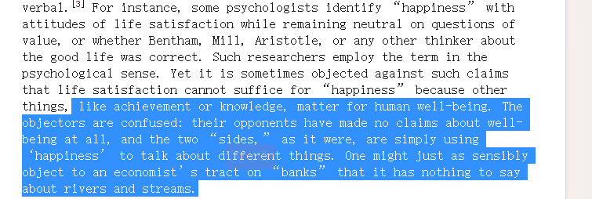

Happiness: emotional state view
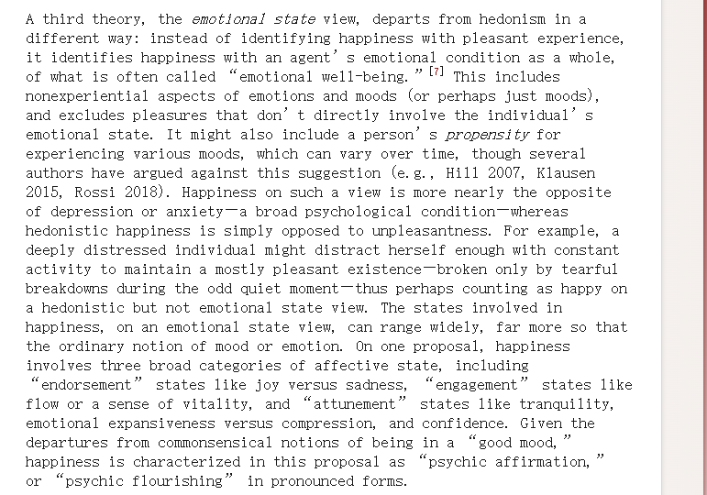
Subjective well-being test
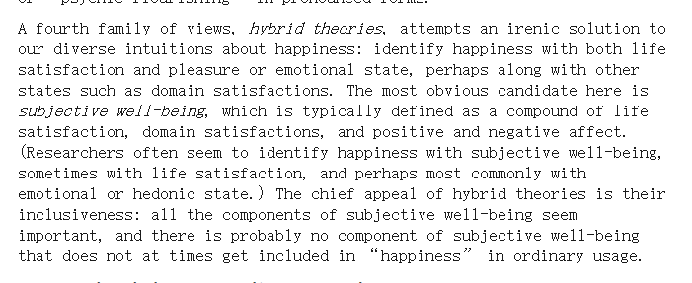

People make decisions only based on now
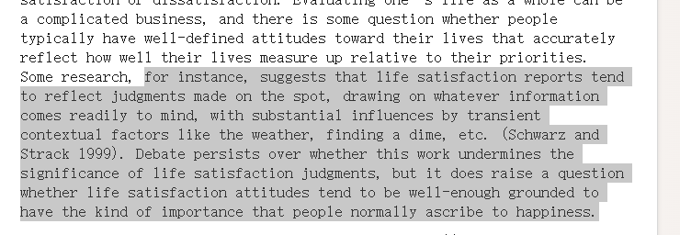
The uneffectiveness of benchmark
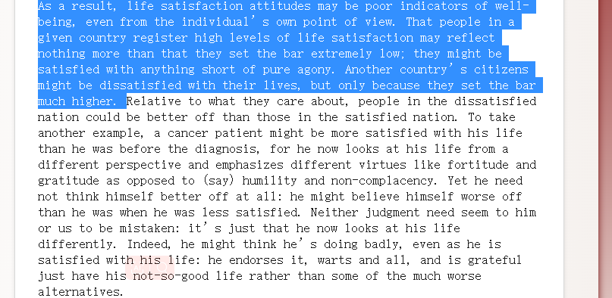

2.4 Hedonism versus emotional state

我现在的逻辑线：
定义：happiness is “objective”(such as eudamonia).
Internal:
To measure one’s potential happiness, one needs to know what makes one happy, how to be happy--knowing is the zero condition

Knowing itself is a difficult process, and even if one believes that he/she knows him/herself, it may still be their cognitive bias( analyze it under each archetype)

External:
After a person knows oneself, he/she needs to transfer the message to the test
First it may be hindered by the respondents’ willingness; Second the frame cannot capture one’s potential happiness

Loneliness--is a social pain
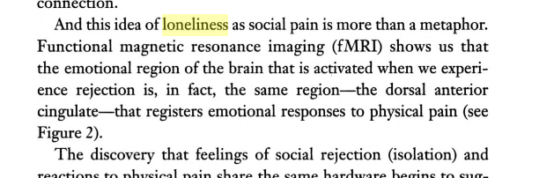
Our function is heavily influenced by the social world

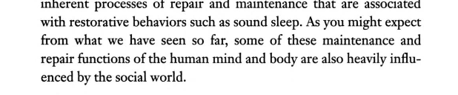

Moreover, the test frame should be based on individuals' understanding of happiness rather than society's cognition. Whether individuals' and externality's cognitions converge can hardly be proved under the influence of mainstream culture.

Objectively investigate--benchmark

Biological approach has potential to measure the intricate activities of brain, but whether the state of brain is associated with happiness can only be certained when one understand the state of knowing, since knowing is the benchmark of subjective measurement.

